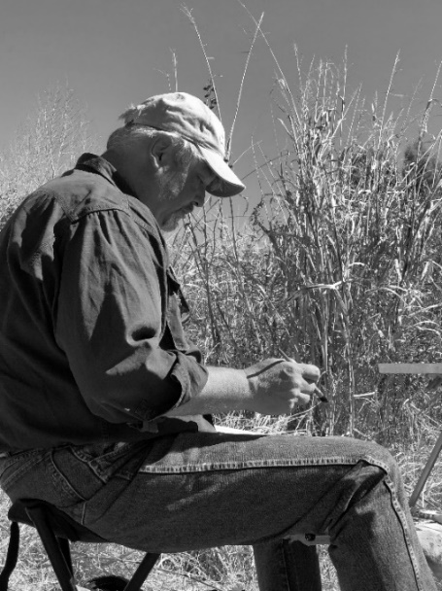 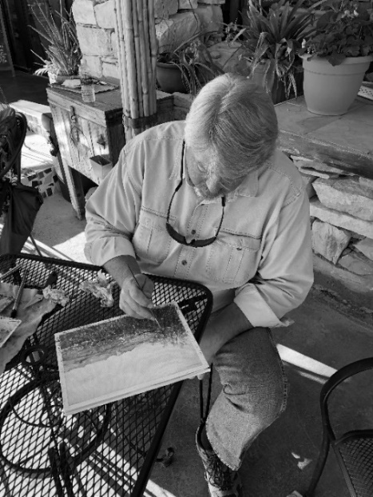

**JEFF WILLIAMS WATERCOLOR**

I came to painting later in life. After a career in architecture and education (teaching design and drawing), I retired with the goal of traveling and learning to paint, expecting this combination to provide continued stimulation throughout the remainder of my life. Through architecture I was inspired by the beautiful watercolor renderings of old, and plein air painting was recommended to me as the best way to learn, thus my painting journey began there. Not long after, I serendipitously found my way onto the *plein air circuit,* with my first years on the circuit spent learning to paint in the challenging medium of watercolor. The circuit provided the very enjoyable challenge of constantly painting/experimenting with new subjects in new locations, under pressure and time constraints. I met and learned from wonderful peers and patrons, put in many brush miles, and I was fortunate to find success along the way.

I continue to experiment in some way with each painting. Early paintings were typically inspired by a discovered composition, lighting condition or subject. At this point in my development, these efforts absorbed all of my attention. However, eventually I wanted more. While continuing to paint extensively on the plein air circuit, the last few years have also been spent exploring the *idea* of painting. As a result, I have done extensive reading about art history as well as about various artists’ lives, trying to understand why they painted, what ideas were behind their paintings, and why others are moved by their work. In addition, I regularly inquire why my peers paint, trying to discover the same from them. (There is always more to learn!)

I have also stepped back and surveyed my own paintings. What I discovered is that whatever I choose to paint must feel *“authentic”* to me. In my earliest work I was enamored with nature, feeling that it provided a freedom that the constraints of architecture had not provided. Eventually, however, I became quite *intrigued with the relationship between the man-made and natural worlds*, often complimenting organic shapes and man-made forms. As I *search for beauty and truth* in the world around me, I enjoy finding this in the everyday scenes around us. In addition, the *passage of time* has become a common theme in my work, often in quite different ways (documenting the history of a subject; capturing the patina of a wall, tree or rock; capturing seasonal changes; celebrating the various seasons of nature; bringing attention to the sculptural qualities of a dead tree or decaying building; etc. etc.).

I do not know where my work will go from here, but I do know that I will continue to be curious and experiment. As I continue to work en plein air, I am also exploring larger watercolor paintings that are begun in the field, from life, but completed in the studio, painting the regional landscape around my home (Oklahoma/Texas). I am also experimenting with oil painting as a compliment to watercolor. We shall see where that goes! What a privilege it is to be able to dream, enjoy and explore!

**RECENT RECOGNITION for JEFF WILLIAMS**

One of 35 artists nationally to be juried into Cape Ann Plein Air 2024 by Selection Juror Charlie Hunter, held in Cape Ann (Essex, Gloucester, Manchester-by-the-Sea and Rockport), Massachusetts, October 5-13, 2024

One of 30 artists nationally to be juried into the 2024 Parrsboro International Plein Air Competition by judge Richard Sneary, held in Parrsboro, Nova Scotia, Canada, June 17-22, 2024; *“Low Tide”* was awarded *Best Seascape* by judge Richard Sneary

One of 28 invited “Featured Artists” at the 2024 Olmsted Plein Air Invitational, to be held in Atlanta, Georgia, April 13 – 24, 2024.

One of 30 artists nationally to be juried into the 2024 Shadows-on-the-Teche Plein Air Competition by judge John Poon, held in New Iberia, Louisiana, March 9-16, 2024

One of 30 artists nationally juried into the 10th Annual *2023 En Plein Air Texas*, held in San Angelo, TX, October 19-29, 2020

One of 35 artists nationally to be juried into Cape Ann Plein Air 2023 by Selection Juror Patrick Lee, held in Cape Ann (Essex, Gloucester, Manchester-by-the-Sea and Rockport), Massachusetts, October 8-15, 2023; “Rockport Eye Candy” won the *Best Small Award* by judge Tim Newton

One of 30 Invited Artists to participate in the 10th Annual 2023 Bath County Plein Air Festival by their Jury of Submissions Committee, held in Bath County, Virginia, September 25 - October 1, 2023

One of 58 artists internationally to be juried into the Easton Plein Air 2023 by judge Nancy Tankersley, held in Easton, Maryland, July 14-23, 2023

One of 30 artists to be juried into the 2022 Mountain Maryland Plein Air Competition by judge Charlie Hunter, held in Western Maryland, June 12, 2023–June 17, 2023; *“Rail Reflections”* was awarded 2nd Place in the *Quick Draw Competition* by judge Charlie Hunter

One of 30 artists internationally to be juried into the 2023 Paint Annapolis Plein Air Competition, held in Annapolis, Maryland, June 4-11, 2023; *“Stribling Walk”* was awarded *1st Place/Specialty Awards* as the *Best Naval Academy Painting*

One of 23 artists nationally juried into the *2023 Winter Park Paint Out*, hosted by *The Albin Polasek Museum & Sculpture Gardens,* to be held in Winter Park, Florida, April 23-30, 2023.

One of 28 invited “Featured Artists” at the 2023 Olmsted Plein Air Invitational, to be held in Atlanta, Georgia, April 15 – 23, 2023.

One of 30 artists nationally to be juried into the 2023 Shadows-on-the-Teche Plein Air Competition by judge Dawn Whitelaw, held in New Iberia, Louisiana, March 11-19, 2023

One of 30 artists nationally juried into the *2023* *Lighthouse ArtCenter Plein Air Festival*, held in Jupiter, Florida, March 5-11, 2023; withdrew due to my wife’s illness

One of 30 artists nationally juried into the 9th Annual 2022 Bath County Plein Air Festival by their Jury of Submissions Committee, held in Bath County, Virginia, September 26 - October 2, 2022

One of 58 artists internationally to participate in Easton Plein Air 2022 (automatic acceptance as a result of my PAE 2021 Third Place finish), held in Easton, Maryland; withdrew due to contracting Covid

One of 30 artists internationally to be juried into the 2022 Paint Annapolis Plein Air Competition by judge Valerie Craig*;* withdrew due to contracting Covid

One of 23 artists nationally juried into the *2022 Winter Park Paint Out*, hosted by *The Albin Polasek Museum & Sculpture Gardens,* held in Winter Park, Florida, April 24-May 1, 2022.

One of 28 invited “Featured Artists” at the 2022 Olmsted Plein Air Invitational, held in Atlanta, Georgia, April 16 – 24, 2022.

One of 30 artists nationally to be juried into the 2022 Shadows-on-the-Teche Plein Air Competition by judge Mark Boedges, held in New Iberia, Louisiana, March 12-18, 2022; “Sunset on the Crawfish Pond” won Fourth Place

Featured artist on the *Plein Air Easton Podcast*, Season 2, Episode 11, *“Competing With Yourself, with Jeff Williams,”* which aired December 3, 2021

One of 30 artists nationally juried into *2021 En Plein Air Texas*, held in San Angelo, TX, October 22-30, 2021; “Texas Weeds” won a *Mini-Pearl Award* as one of the best small works paintings by judge Tim Newton

One of 58 artists internationally to be juried into the Easton Plein Air 2021, held in Easton, Maryland (this is the largest and most prestigious plein air event in the USA!); Williams’ painting *“Another Beautiful Day in Oxford”* was selected as the Third Place winner by the awards judge, President and CEO of *The Metropolitan Museum, NYC, Daniel H. Weiss.*

One of thirty artists internationally to be juried into the 2021 Paint Annapolis Plein Air Competition, held in Annapolis, Maryland, June 5-12, 2021

Invited participant in the 8 person exhibition *“The Rattlesnake Gang Presents Big Bend National Park,” Art Gallery Prudencia*, San Antonio, Texas, April 10 – May 23, 2021.

*“Winter Silence*” was selected to be in the national juried exhibition *“Landscapes to Explore,”* to be held at the *Kansas City Stockyards Gallery* March 19 – April 9, 2021

*“Rockin’ Bass Rocks”* was one of 106 paintings (from almost 1,000 submissions) juried into the *National Watercolor Society 2021 Members Exhibition* by juror Mat Barber Kennedy

One of 43 artists selected for inclusion in the national juried show *"Street Scenes 2021"* hosted by the *Maryland Federation of Art*; of 371 entries, 57 entries were selected, including three of Williams’ paintings: *"Smith Lake, Washington Park, Denver, Colorado,” “Grand Marais Industrial Building Quick Draw,”* and *“Dreams of Traveling Again, Stillwater Regional Airport”*

One of 30 artists nationally juried into *2020 En Plein Air Texas*, held in San Angelo, TX, October 17-24, 2020; “Cactus Hotel” won a *Mini-Pearl Award* as one of the best small works paintings by judge Tim Newton

Invited artist participant representing the state of Oklahoma for *The Great American Paint In™,* <https://thegreatpaint-in.com/>

Invited Selection Judge for the *2020 Plein Air Painters of New Mexico National Exhibition*, Fall 2020

Invited Interviewee for online video by the Australian videographer and watercolor painter, *Art With Sylvie,* July 2020

One of 30 juried artists nationally to be juried into the *2020 Harford Plein Air Festival* by judge Ray Hassard, held in Harford County, Maryland, (Declined due to COVID-19 pandemic)

One of thirty artists to be juried into the 2020 Mountain Maryland Plein Air Competition, held in Western Maryland, June 15-20, 2020

“Rockin’ Bass Rocks” won the “Outstanding Watercolor” award as well as was recognized as part of the “FAV15” in the January 2020 online Boldbrush Painting Contest

One of thirty artists internationally to be juried into the 2020 Paint Annapolis Plein Air Competition by juror Vladislav Yeliseyev, held in Annapolis, Maryland, June 2-9, 2020

One of 58 artists internationally to be juried into the Easton Plein Air 2020 by juror Julia Marciari-Alexander, held in Easton, Maryland, July 12-19, 2020

One of twenty eight artists nationally to be juried into the inaugural Plein Air New Bern b*y* juror Nancy Tankersley, held in New Bern, North Carolina, May 11-16, 2020

One of thirty artists nationally to be juried into the 2020 Shadows-on-the-Teche Plein Air Competition by juror Kenn Erroll Backhaus, held in New Iberia, Louisiana, March 14-21, 2020

“All Aboard!” was recognized with an Award of Excellence in the Art of the Plains 2019 American Plains Artists Thirty-fourth Annual Juried Exhibit & Sale by judge Sonya Terpening.

“Distant Memories,” “Ten XXX Ranch, Distant View,” and “All Aboard!” were juried into the Art of the Plains 2019 American Plains Artists Thirty-fourth Annual Juried Exhibit & Sale by judge Sonya Terpening, held at the Pearce Museum at Navarro College, Corsicana, TX, October 10, 2019 through January 4, 2020

“A Rainy Friday on McElroy” was juried into The Artist of Northwest Arkansas’ Celebration of Art National Juried Exhibition by entry judges John Pototschnik, Larry Seiler and Rod Zullo.

Juried into the 7th Annual 2019 Bath County Plein Air Festival by their Jury of Submissions Committee, held in Bath County, Virginia, September 30 - October 6, 2019 (Declined due to schedule conflicts)

Juried into the 4th Annual *2019 Bucks County Plein Air Festival* by their Selection Committee, held in Bucks County, Pennsylvania, October 1-6, 2019 (Declined due to schedule conflicts)

One of 40 artists nationally to be juried into Cape Ann Plein Air 2019 by Selection Juror Mark Boedges, held in Cape Ann (Essex, Gloucester, Manchester-by-the-Sea and Rockport), Massachusetts, October 6-14, 2019, where “Morning at the Docks” won the *Best Nocturne Award* by judge Kenn Erroll Backhaus

Juried into the 16th Annual 2019 Plein Air Grand Marais by their Selection Committee, held in Grand Marais, Minnesota, September 6-13, 2019

One of twenty three artists nationally to be juried into the inaugural 2019 Central City Plein Air Festival by judge Bruce Gomez, held in Central City, Colorado, September 27-29, 2019

One of 30 juried artists nationally to be juried into the 2019 Harford Plein Air Festival, held in Harford County, Maryland, October 6 - 12, 2019 (Declined due to schedule conflicts)

“Lake Carl Blackwell Backwaters” and “Barn East of Stillwater” were juried into the exhibition "Home Sweet Oklahoma," *Hazel Modella Gallery*, Stillwater, OK, May 30 – June 29, 2019

“Almost Home” was recognized as part of the “FAV15” in the February 2019 online Boldbrush Painting Contest

One of twenty two artists nationally to be juried into the 2019 Two Rivers Plein Air Competition by judge Qiang Huang, held in New Braunfels, Texas, April 30 – May 3, 2019

One of forty one artists nationally to be juried into the 2019 Finger Lakes Plein Air Competition by judges Jo Ellen Murphy, Vlad Yeliseyev, and David Lussier, held in Canandaigua, New York, June 4-9, 2019 (Declined due to schedule conflicts)

One of thirty artists nationally to be juried into the 2019 Parrsboro International Plein Air Competition by judge Nancy Tankersley, held in Parrsboro, Nova Scotia, Canada, June 20-23, 2019 (Declined due to schedule conflicts)

One of thirty artists internationally to be juried into the 2019 Paint Annapolis Plein Air Competition by judge Valerie Craig, held in Annapolis, Maryland, June 2-9, 2019; “St. Mary’s from the Pier” won Third Place in the Dueling Brushes (Quick Paint); “Sixth Street Bridge (Eastport Bridge), Annapolis” won Second Place in the Art on the Avenue event (Jo Fleming, juror); “Sixth Street Bridge (Eastport Bridge), Annapolis” won Honorable Mention (Larry Moore, juror)

One of twenty five artists nationally to be juried into the 2019 Telluride Plein Air Competition, held in Telluride, Colorado, June 30 - July 6, 2019

One of thirty artists nationally to be juried into the 2019 Shadows-on-the-Teche Plein Air Competition by judge Morgan Samuel Price, held in New Iberia, Louisiana, March 9-16, 2019; “Bridge at Cypremort Point” won the Nocturnal Award as the best nocturne painting in the show

"Storm Clouds Move Across Highway 177” was accepted into the Arkansas Territory Bicentennial Show, a two-year traveling exhibition and commemorative book sponsored by the Heart of America Artists’ Association celebrating 200 years of the Arkansas Territory

9 paintings were juried into the exhibition "Zen and the Art of Motorcycle," Hazel Modella Gallery, Stillwater, OK, January 17 - February 24, 2019

“Almost Home” was recognized as a Finalist in the January 2019 online Emerging Artist Art Muse Contest, by judge Jill Basham

“A Rainy Friday on McElroy” was recognized as a Finalist in the November 2018 online Emerging Artist Art Muse Contest, by judge Nancy Tankersley

“Russian and Autumn Sage in Fall” was recognized as part of the “FAV15” in the September 2018 online Boldbrush Painting Contest

3 paintings juried into the American Plains Artists (APA) 33rd Annual Juried Exhibit & Sale, San Angelo, TX, 2018; “Barn Southwest of Perkins 2” was awarded the Best Landscape Award by juror and gallery owner R.S. ”Shannon” Hanna, of R.S. Hanna Gallery in Fredericksburg, TX

2nd Place, Quick Draw Competition, 2017 En Plein Air Texas, San Angelo, TX